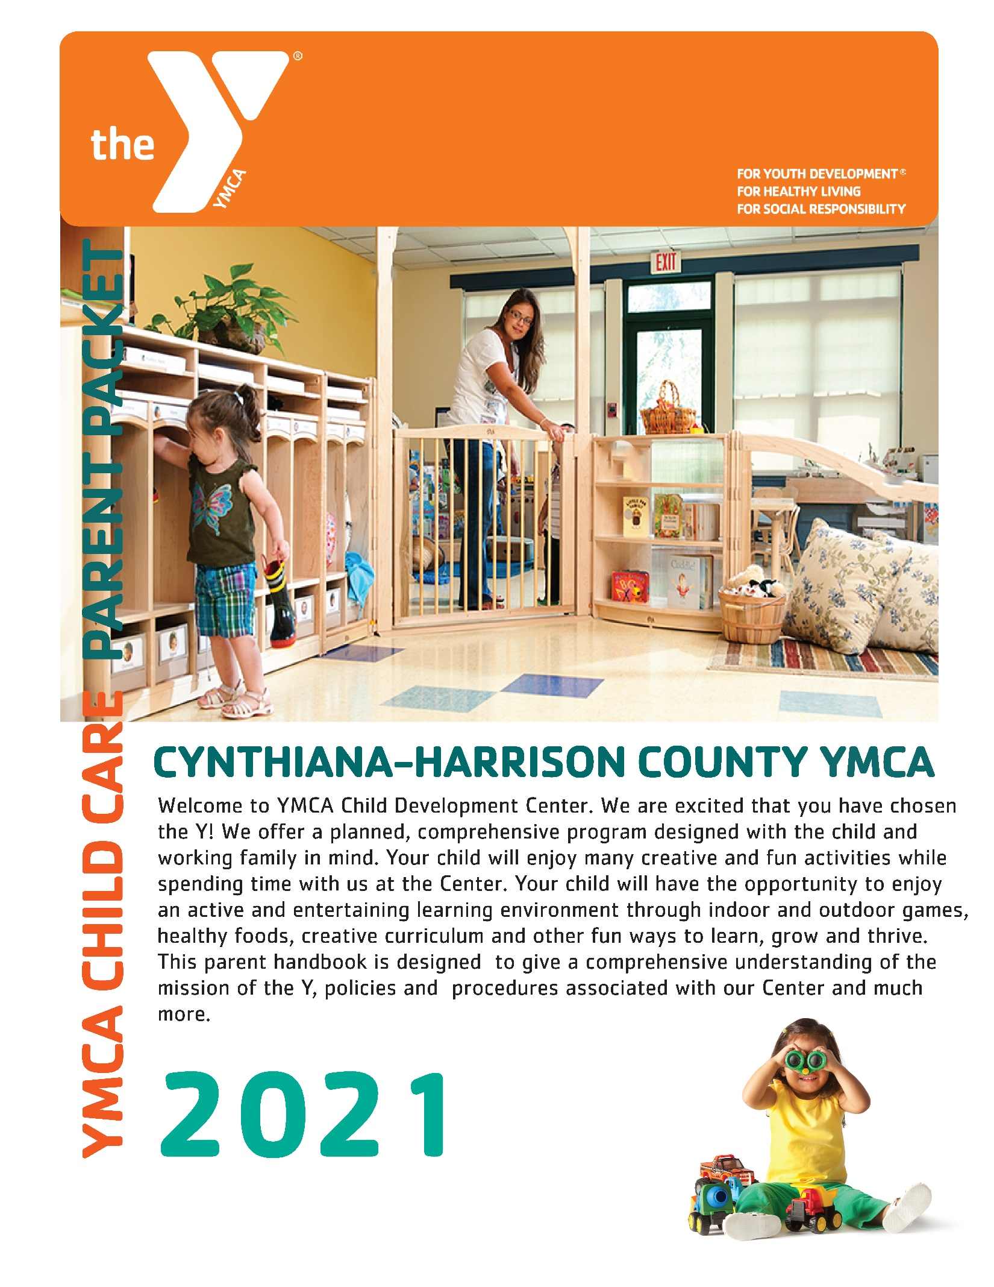
Cynthiana-Harrison County YMCA
Child Development Center
Parent Handbook

Welcome
This handbook is to inform you of the policies and procedure under which the YMCA Child Development Center operates as a licensed Child Care Center. Your child will receive an enriched, planned curriculum that will allow your child to develop his/her abilities to the fullest. You are welcome to visit at any time.
Mission
- To provide an environment to help children develop physically, emotionally, socially and intellectually through active participation in a variety of educational experiences.
- To put Christian principles into practice through program that builds a healthy spirit, mind and body for all.
Objectives
- Provide safe, high quality programs
- Employ well trained teacher and counselors
- Offer a variety of stimulating activities
- Provide a community not only for the children, but their family.
- Model and encourage the character values of CARING, HONESTY, RESPECT and RESPONSIBILITY

Enrollment Requirements
- Attend an intake interview and complete the enrollment application and accompanying documents.
- Read and sign releases regarding payment, behavior policy, medication administration, field trips, emergency disaster and emergency medical care.
- Provide proof of up-to-date vaccinations and continue with all required vaccinations and provide an updated proof as they occur.
- Complete and renew CACFP forms annually and CCA forms if applicable.
- Pay the non-refundable registration fee of $25.
- Sign your child in and out each day and add your signature to the attendance form on the last day tending each week.

All enrollment information must be kept up to date for the safety of the children. Should any information on your child change the YMCA must be notified immediately.

Open Door Policy
Parents are free to visit the child care center at any time during hours of operation. Parents are welcome to volunteer their time or just observe their child’s activities at the center.

Payment for Services
Payments must be made through electronic fund transfer (EFT) via your checking or savings account or debit or credit card (MasterCard or Visa). Child care payments are due and drafted each Friday before the week of child care service. In the event of a returned draft, you must pay the amount due, plus a $25 fee. If you become more than two weeks behind in you payments your child will be unable to return to the program, until payment has been paid in full and CCAP or other financial scholarship sponsors will be notified. It is the Parent/Guardians responsibility to let the director know if any changes are made to your account that may cause the draft not to go through successfully. Bank Draft forms are included the registration packet and can be obtained at the YMCA front desk.

Weekly Classroom Fees
 | Full Time  (4-5 days) | Part Time  (2-3 days)
Infants/Toddlers (6 wks - 24 mos.) | $150 | $110
Preschool  (2-5 years) | $145 | $105

Annual Fees
We charge an annual fee for our program. The cost of the fee is $25.00 per child. Children enrolled in the Child Development Center the fee is January to January. This amount will be taken out in January of each year.

Vacations
Children enrolled full time are allowed 2 weeks of non-payment for vacation per school year September 1 - August 31. We must receive written notification 2 week prior to your vacation to ensure drafts will not be made to your account.

Hours of Service/Child Schedules
Child Care service hours are regularly available between 6:30am and 6PM, Monday – Friday. Children can be in care for up to 10.5 hour each day. At the intake meeting parents will establish what their care days and hours are going to be. These are the hours that their child/children will be expected to arrive and depart on the days scheduled. We ask for this so that we can assure that we have the appropriate number of staff on site when your child/children arrive. To establish a part-time schedule you will need to choose which 2-3 days you will be using. If you wish flexibility to come any 2 or 3 days out of the week you will need to pay full time rates. As a part-time participant we will attempt to fill the empty days with another part-time child. We cannot guarantee that reduced hours will be approved. We reserve the right to alter our hours due to inclement weather or staff training sessions.

Holidays
All child care programs will be closed on the following days listed below.
- Memorial Day
- Independence Day
- Labor Day
- Thanksgiving Day
- Christmas Eve
- Christmas Day
- New Year’s Day

Limited Hours will be available on the following day.
- New Year’s Eve (6:30 a.m. - 2:00 p.m.)
There will be no discount when the center is closed for a holiday.

Weather Policy
When conditions are hazardous for driving there may be a possibility that we will delay opening the center or close the center. This will be decided at the Director’s discretion no later than 5:30 a.m. the morning of the delay or close. The delay or closings will be announced on Lexington television stations (Channels 18, 27 and 36). Delays and closing will also be found on the Cynthiana-Harrison County YMCA facebook page.

Arrival and Departure
You (or authorized person) must always escort your child in and out of our facility Your signature (or authorized person) is required when doing this and are required to sign the child in and out of the center each day, including the time in/out and initials, plus a verification signature on Fridays.
Only people authorized by you, on the registration form you have completed, will be allowed to pick up your child. We will not release your child to anyone we don’t recognize. Please don’t be offended if you (or alternate pick up) are asked to show identification. This is to ensure the safety of your child.
There is no reduction in fees due to a child’s absence, except for schedule vacations. If your child is a participant of the Child Care Assistance (CCA) program your child cannot be absent for more than 5 days each month, unless you have a doctor’s excuse. If you miss more than 5 days you will become responsible for payment of those days missed.

Our center closes promptly at 6pm. If your child is here after 6pm you will be charged $1 for every minute you are late. Emergency contacts will be notified at 6:15pm. Should a child remain at the center one hour past closing the legal authorities will be contacted.
Parents will have to bring children in by 10:00 am. If your child has scheduled appointments that would prevent you from dropping off at the arrival time please notify the Director by phone or email as soon as possible. You will also need to bring in a Doctor’s excuse when you bring your child in. If you do not have an appointment and have not spoken with the Director and your child is not here by 10:00 am they will not be permitted into their classroom until nap time is over in that room. Listed below is a list of classrooms and their nap times. Please keep in mind that if you have more than 1 child you will need to go off the oldest child’s nap time.

Nursery 1: Nap on Demand
Nursery 2: 12:00 – 2:00
Two’s: 12:00 – 2:00
Pre-School: 12:30 – 2:30
Pre-K: 12:30 – 2:30

Food/Meals Policy
The Cynthiana-Harrison County YMCA Child Development Center will supply all food for participating children. The center is enrolled in the Child and Adult Care Food Program and will be serve nutritious meals (breakfast, lunch and afternoon snack according to USDA guidelines. Menus are posted on the parent boards in each classroom as well as on the USDA Food program Board in the Kitchen. If your child has a medical condition such as an allergy or temporary condition where they will need a food substitution, you must have a doctor’s note signed and dated by your child’s physician and that documentation must be up-dated yearly per the Child and Adult Care Food Program. If a menu offers an item that a child cannot eat due to allergy that item will be replaced with a similar item that does not contain the problem food. We are a peanut free facility.
If a child arrives with food, parents will need to either take the food from the child before they enter the classroom or wait in the registration area until the child finishes the food and can go into the classroom.

The center will provided PARENTS CHOICE FORMULA. It will have a variety of infant cereals and baby safe foods on hand to offer. Parents of infants may choose to bring breast milk or other formula and food.

If your child is under 12 months of age and you would like them to drink whole milk you must have a doctor’s note signed and dated by your child’s physician. If your child is over 12 months of age and they are still on formula or breast milk we must have a doctor’s note signed and dated by your child’s physician.
Preparation of Children’s Bottles
Our Center’s policy is that all infants’ bottles are made before they come to the center in the morning. The only way that the infant room teacher will make your child’s bottles is if your child is using the formula that the Center supplies.

Labeling Children’s Bottles
The Cabinet for Health and Family Service, a division of regulated Child Care, requires that all bottles are labeled and have a lid. The lids should be labeled with your child’s first and last initials. The bottle itself should be labeled with your child’s first and last name along with the date that the bottle was made.
If you do not want to write on the bottle you can write on tape and place the tape on the bottle. The best tape to use is masking tape or painters tape.

Special Occasions/Holidays
The Cynthiana-Harrison County YMCA Child Development Center is committed to providing nutritious meals and snacks for all participants on a daily basis. If you would like to celebrate your child’s birthday or other special event with their class you may obtain an approved special occasion/holiday list of items form the Director. You will not be permitted to bring in any other items that is not on the approved list. Special occasions/holidays are fun and can still be fun while being healthy.

Breastfeeding
We know and understand the benefits of breast feeding, therefore the Cynthiana-Harrison County YMCA Child Development Center will support breastfeeding mothers by: providing proper storage of breast milk, encourage mothers to come into the center to breastfeed their child (we do not have a separate area for breastfeeding, however, the staff will provided mothers with a rocking chair or padded area and a blanket for covering if desired), and provided training for staff members regarding breastfeeding and its benefits.
USDA Non Discrimination Policy
The U.S. Department of Agriculture (USDA) prohibits discrimination against its customers, employees and applicants for employment on the bases of race, color, national origin, age, disability, sex, gender identity, religion, reprisal, and where applicable, political beliefs, marital status, familial or parental status, sexual orientation, or all or part of an individual’s income is derived from any public assistance program, or protected genetic information in employment or in any program or activity conducted or funded by the Department. (Not all prohibited bases will apply to all programs and/or employment activities.) If you wish to file a Civil Rights program complaint of discrimination, complete the USDA program Discrimination Complaint Form (PDF) found online at http://www.ascr.usda.gov/complaint_filing_cust.html, or at any USDA office, or call (866) 632-9992 to request the form. You may also write a letter containing all of the information requested in the form. Send your completed complaint letter to us by mail at U.S. Department of Agriculture, Director, Office of Adjudication, 1400 Independence Ave, S.W., Washington, D.C. 20250-9410, by fax (202) 690-7442 or email a program.intake@usda.gov. Individual who are deaf, hard of hearing or have a speech disability and you wish to file either an EEO or program complaint please contact USDA through the Federal Relay Service at (800) 877-8339 or (800) 845-6136 (in Spanish).

Infants Safe Sleep Standards
The Cynthiana-Harrison County YMCA Child Development Center practices safe sleep practices to reduce the risk of SIDS (Sudden Infant death Syndrome). The following standard are practiced in Nursery 1, infants under 12 months of age are:
- Put in their crib on their backs to sleep.
- Are moved to their crib if they fall asleep anywhere other than their crib.
- The classroom is kept at a comfortable temperature throughout the day.
- The only items allowed in the crib when a child is sleeping is a tight fitted sheet, and a pacifier.

Supply Responsibility
Parents/Guardians are responsible for providing all diapers, wipes, ointments or creams for their children. If the supply runs out and the center has to supply diapers, the parents will be charged the cost of purchase on the days they are needed.
Because children learn through their senses they will get messy at times. They will be doing activities that include paint, markers, glue, sand, dirt and other materials. Please dress your child in closing that they can play and move in without the fear of getting dirty. Please always have an extra set of labeled clothing (related to the season) in your child’s classroom, remember potty accidence happen. If a child runs out of extra clothing, parents will be called and are expected to bring more clothes or come to pick up the child for the day.
As the children are using their gross motor skill through the day appropriate footwear needs to be worn. For children who are walking this means supportive closed-toed shoes, such as tennis shoes.

The Y will supply a sheet and blanket for their children to nap with. Security items are welcome during rest periods only and must be kept in their cubbies for the remainder of the day.
Please label all of your child’s belongings. The YMCA does not allow children to bring toys/games from home except on specified days requested by your child’s teacher. The YMCA Child Development Center will not be held responsible for any lost or damaged items brought from home.

Non-Discrimination Practices
The Child Development Center reserves the right to screen applicants for the child care. Decisions will be based on compatibility of the center with the family and their needs, the number of openings available and the hours needed for service. The Child Development Center will not discriminate based on race, color, creed, national origin, religion, sex or disability. We maintain a waiting list.
CARE OF ILL CHILDREN, COMMUNICABLE DISEASES
Management of Illness is for the safety of all children in the program. We cannot allow ill children to attend. Even “mildly ill” children should not be in attendance. A mildly ill child is defined as someone who is experiencing minor cold symptoms. To ensure the health and well-being of all children in our program, if a child has a contagious illness, infection or fever of 100 degrees parents or authorized persons will be notified to pick the child up.
If a child cannot participate in the regularly scheduled programs, he/she should remain at home. A child who becomes ill during the day will be discharged to the care of his/her parent or guardian as promptly as possible. If the parent or guardian is unable to pick up the child, the staff will discharge the ill child to the person who has been designated by the parent. The YMCA should be informed of the nature of any illness your child has contracted. In the case of exposure to a communicable disease, parents will be notified by parent letter.

Isolation Precautions
A child isolated due to a suspected communicable disease or symptoms of a communicable disease shall be:
• Within sight and hearing of an adult at all times.
• Cared for in another room or portion of a room away from other children.
• Made comfortable in an area. The area will be disinfected with a germicide, or if soiled with blood, feces, vomit or other body fluids, the area shall be cleaned with soap and water and disinfected

All staff members are trained to recognize the signs of communicable diseases and other illnesses. A trained staff member will observe each child as he or she enters the program. All children will be required to wash their hands upon entering the program area and prior to eating. Any child who develops the following symptoms while in our program will be isolated immediately in the designated First Aid area until discharged to his/her parent or guardian.

The symptoms include:
• Temperature of at least 100°F when in combination with any other sign or symptom of illness.
• Severe coughing, causing the child to become red or blue in the face or to make a whooping sound.
• Difficult or rapid breathing.
• Yellowish skin or eyes.
• Redness of the eye, obvious discharge, matted eyelashes, burning, itching of the eyes.
• Unusually dark urine and/or gray, white, or yellow stool.
• Stiff neck with elevated temperature.
• Vomiting more than once or when accompanied by any other sign or symptom of illness.
• Diarrhea (three or more abnormally loose stools within a twenty-four hour period).
• Evidence of untreated lice, scabies or other parasitic infestations.
• Untreated infected skin patches, unusual spots or rashes.
A child exhibiting any of these symptoms or has a communicable disease will be isolated and discharged and may be readmitted to the program after he/she is free from all symptoms for 24 hours and we are provided a doctor’s note clearing them to return to group care.

Medication
In order for the Y to dispense medication for your child the following is required: 1) A medication form must be filled out daily in order to dispense (the teacher or director will have this form) 2) Medication must be in the original bottle for the person it was prescribed, with the dosage for the day only. 3) The parent or guardian must bring in the medication and give it to the teacher or director. Over the counter medication (Tylenol, Benadryl, etc.) will only be dispensed with a note from a physician on letterhead. Please give this note to the teacher or director along with your daily permission to administer.

Immunizations
Children are required to be up-to-date on all vaccinations required by the Kentucky School System and Commissioner of Health. Documentation of vaccinations must be provided to the day care at enrollment and updated as boosters are received.
Medication Administration
State regulations require medication only be administered with written orders from the physician and daily written instructions from a parent. Parents are responsible for supplying any medication administered to children. The medication must be in its original container, have an original label with the child’s name, expiration date and dosage instructions. The Child Development Center will not administer medication unless the child’s physician specify that the medication must be administered during the center hours of operation. Medications that require less than 3 doses daily do not meet this requirement and will not be administered. Over-the-counter medications such as Tylenol, will not be administered. If your child has an allergies where Benadryl, an EpiPen, etc. may need to be used to avoid a serve allergic reaction a doctors diagnoses of the condition will be needed to administrate. Diaper Cream and Sunscreen is also considered a medication, therefore, each child must have his/her own bottle labeled with his/her name and permission to administer must be given. Permission to apply both Diaper Cream and Sunscreen is in the registration packet.
Emergency Procedures
Staff are trained in CPR and First Aid. Each room (including after school and Summer Camp) has its own first aid kit available. Parent will be contacted immediately in the event of an emergency. We may contact the emergency Medical Service to assist us or transport the child to the hospital. Your child will always be accompanied by a YMCA staff member. We carry liability insurance only so families should carry their own accident insurance. It is vital to your child’s health and safety that you keep registration and emergency forms updated.
Outdoor Play
The National Health & Safety Standards for Child Care recommend that child care providers take children outside at least once every day, as long as the weather is not severe. If you requests that your child not go outside, we will need a written explanation from your child’s physician, to exclude them from this activity. Even on days when it may be too cold to play for an extended period of time, a short walk can be beneficial. Staff and children alike feel rejuvenated when outdoor play is part of the daily routine.

Dressing for Outdoor Play
Children need to be dressed appropriately to play outdoors safely. Please make sure your child have the following winter clothing with them every day so they can play outdoors during cold weather:
- Hat (as much as 50% of a person’s body heat can escape from his/her head)
- Mittens/gloves (mittens keep hands warmer)
- Boots or water resistant shoes.
- Winter coat

Termination of Services
Termination of the contract can be accomplished by either the provider or parent/guardian with 2 weeks written notice of last day of service. The cost of services will be charged to parents/guardian regardless of whether service is provided until the last day of the 2 week notice. The provider may terminate services without notice if parent/guardian fails to comply with the contract terms. The failure of YMCA to enforce one aspect of these policies does not waive the right of the child care to enforce any other terms of the policies.
Substitute or Helpers
Your child’s classroom will have regularly scheduled staff. However during the start and end of each day, daily break times, staff vacations or when new staff is hired, there will be substitutes in the classroom. All staff undergoes background checks, professional training hours and classroom training experience
Pets
The day care center may have small enclosed classroom pets (fish, etc.) as part of a learning curriculum. Please include animal and other environmental allergies on the registration forms so that we can ensure the health and safety of your child.
Tobacco Policy
The YMCA has a tobacco free campus including E-cigarettes.
Alcohol and Drug Use
The YMCA has an alcohol and drug policy that includes a pre-employment drug screening and random drug screenings. No caregiver will be impaired by drugs or alcohol while supervising children or in the presence of children.
Behavior Management Policy
Our goal is to help children learn to live life comfortable with themselves and others. In order to achieve this, each child is held accountable for his/her own actions. Discipline consists of positive guidance techniques and time away from others. We prohibit children from using profanity, as well as committing any acts of violence (physical or verbal), and destruction of property while in our program. All parents must sign the behavior policy agreement before their child can enter our programs.
Children need structure in their life to learn their limits. They will also test limits. Each classroom has a daily schedule that will be followed as much as possible. Children will have the opportunity to make choices in their day. There will be rules that need to be followed.
1. Safety First – toys, games and activities need to be used/played in the way they were intended
2. Children will have choices but a choice doesn’t include behavior that hurts others.
3. Natural consequences result in meaningful new learning. Whenever possible, natural consequences will be used.
4. Talking about problems will be encouraged, distracting children from situations that are frustrating, and giving children alternate outlets for frustration will be methods teaching children to deal with problems.
5. Re-direction of child to an alternate activity or to cue toward more acceptable behavior.
6. At the time of pick up, parents/guardians will be notified if their child has demonstrated aggressive behavior unless the level of behavior requires immediate parenting attention. Parents/guardians may be asked to pick a child up if the aggressive behavior is significant or appears to be out of control.
7. At the time of pick up parents will be notified if their child has been aggressed against unless parents request immediate notification. If a child is injured and may require medical attention, parents/guardians
will be notified immediately.
Biting Policy
The YMCA Child Development Center recognizes that it is not out of the ordinary for young children between the ages of 10 and 30 months of age to go through a period of biting. Biting occurs for a variety of reasons. Some of the most common reasons young children bite are due to teething, lack of ability to communicate, frustration, being overly hungry, and/or a need for more attention. It is highly likely that all children between these age ranges will either bite or be bitten at some point (often more than once) while in the child care setting.

Our teachers and administration work closely and quickly to extinguish this undesirable behavior by following these guidelines for children who have been identified as having a biting habit.

If a child bites three (3) times in one day, the parents will be called and required to remove the child from the center for the day.

If a child has been required to leave the facility for the aforementioned reason twice within a five (5) day period, a parent/teacher/Director conference will be held. During this conference, a formal plan of action will be developed.

After the parent/teacher/Director conference, if improvement is not seen, the parent will be required to temporarily withdraw the child from the Center.

After a temporarily withdrawn child returns, if improvement is not seen, the child will be required to be taken out of our permanently.

Grievance Policy
If a parent/guardian has a concern about the service, costs or other areas; they should address it with the Child Care Director. The Director will take their concerns under advisement and decide on a course of action. If the parent/guardian and the Director don’t come to a solution, the parent/guardian may consult the Executive Director of the YMCA or the parents may choose to give their 2 weeks’ notice to remove their child from the day care. All efforts will be made to meet the needs of the parent/guardian; however the YMCA determines policy at the day care.
Mandatory Reporting of Abuse, Suspected Abuse or Neglect
We make every effort to prevent child abuse by rigorous hiring practices that include reference checks of past employers, organizations, drug screening, criminal background checks as well as extensive developmental training. We conduct periodic evaluations with children and parents about their daily experiences and encourage reporting of anything out of the ordinary. YMCA staff is required to report any suspicion of child abuse/neglect to social services. We promote safety of children through the practices of not leaving a staff member alone with children. Children are separated by age groups during activities such as restroom visits, field trips, etc. All YMCA staff follows a code of conduct policy for the protection of your children.
Observation and Assessment Policy
Periodically, as part of the normal course of care; behavior, activities and achievements will be documented. The results of these observations will be offered to parents in the format of a written summary.
If your child has an active Individualized Education Plan (IEP) or Individual Family Services Plan (IFSP), the YMCA wishes to take part in the planning and implementation of the plan as it relates to their time in programming. Any assessment information will be shared with the appropriate (with parent’s written permission) parties.

